

1. Step 1: Creating constructor function for initialisation of the object.

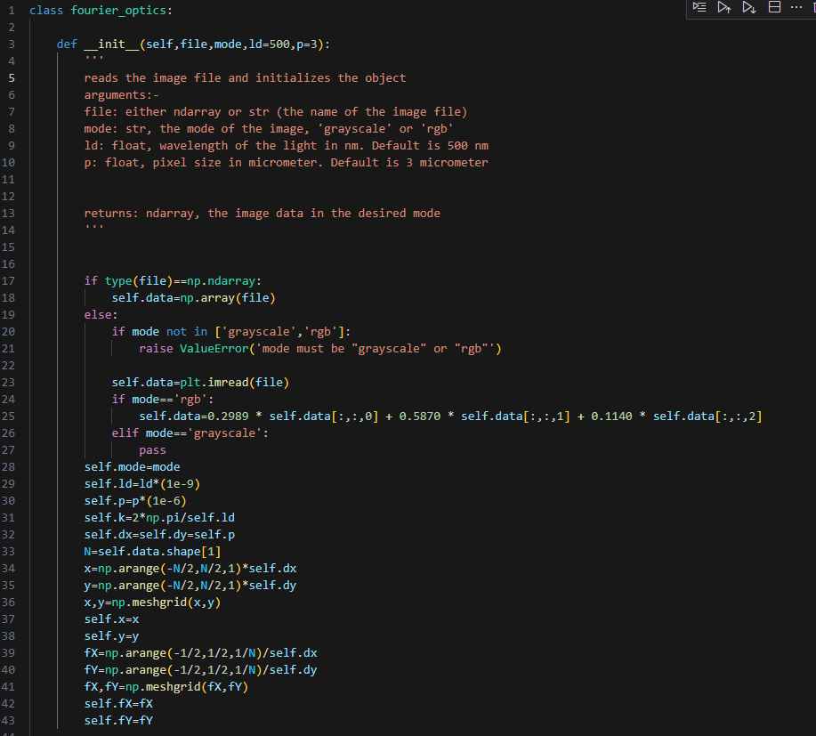

1.b)

Many properties of the system are used multiple times. Here, we save them as object attributes so that we do not have to calculate them multiple times.

*1.a) Our class supports 2 input formats- either string (filename) or numpy array.*



1. Step 2: Creating helping functions:
2. When we copy a list just by-

new_list=list_name

We get a shallow copy. It means that when we make changes in new array using subscript, old array is also changed. E.g.,

new_list[1]=5

list_name is also changed

To avoid this we make deep copy.

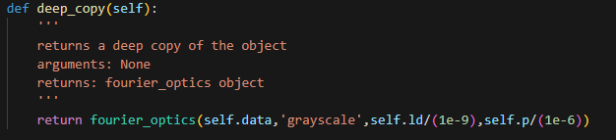

1. Fourier Transform

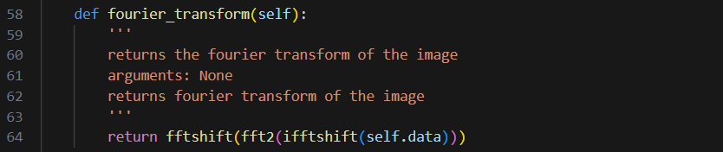

1. Diffraction

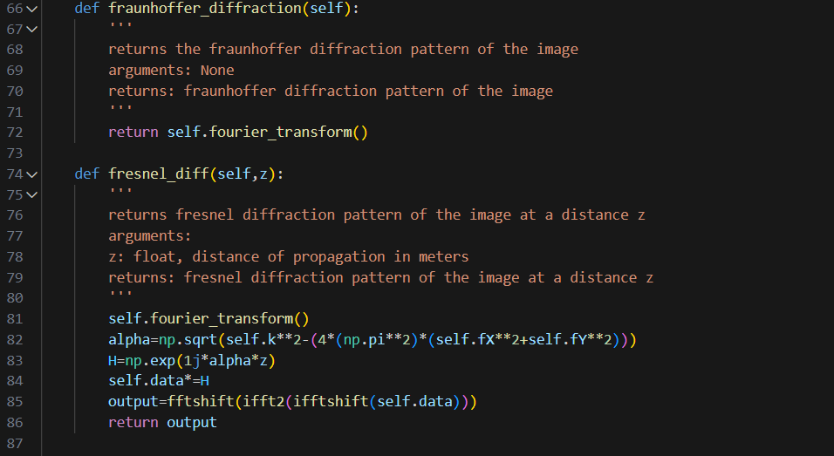

1. 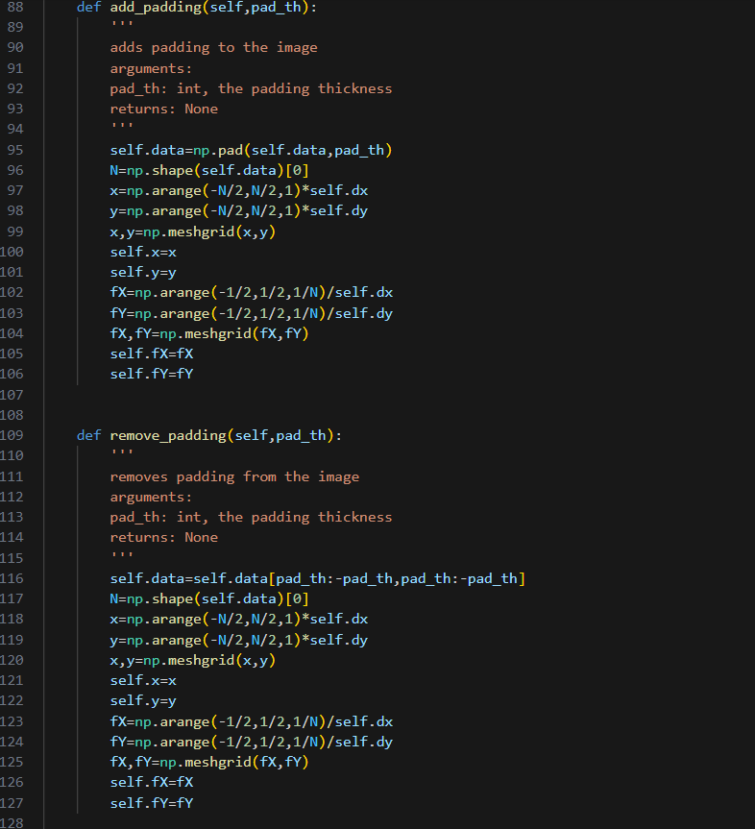Add padding and remove padding:
2. Angled illumination:

To simulate effect of angled illumination

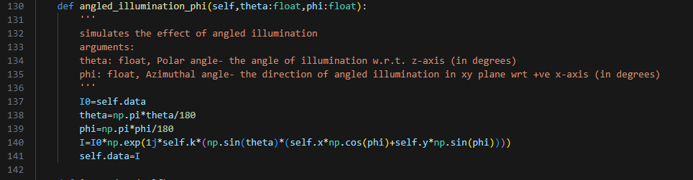

1. Extracting the data from the object using method:

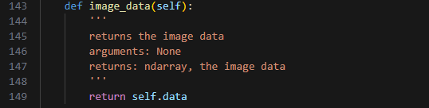

1. 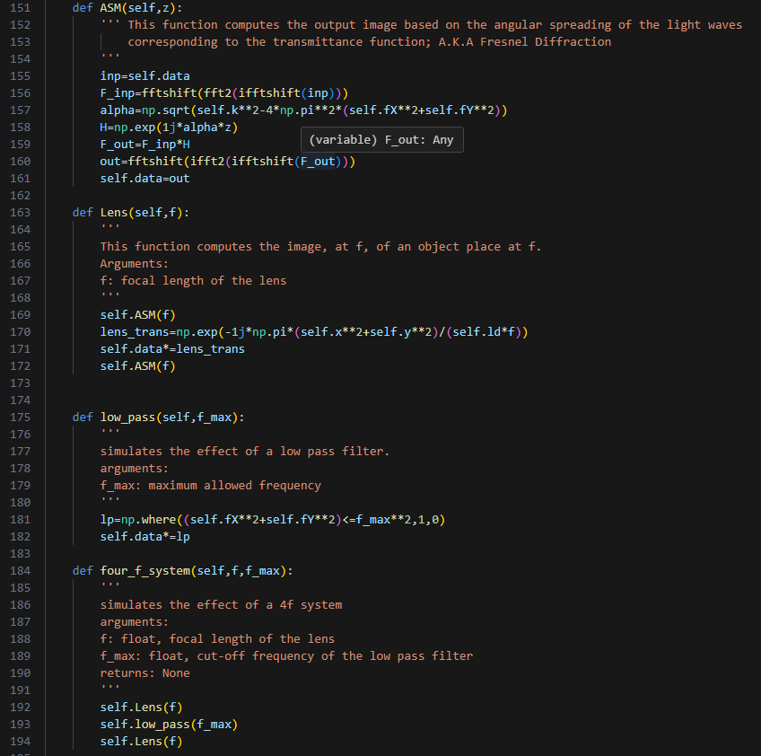Step 3: Elements of Fourier optics:
2. Normalizing data:

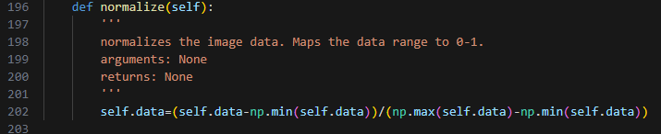

1. Actual project:
   1. Initializing values:



* 1. Creating the object:



* 1. Preprocessing the data:

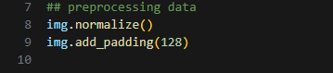

* 1. Simulation of angled illumination and plotting the result :

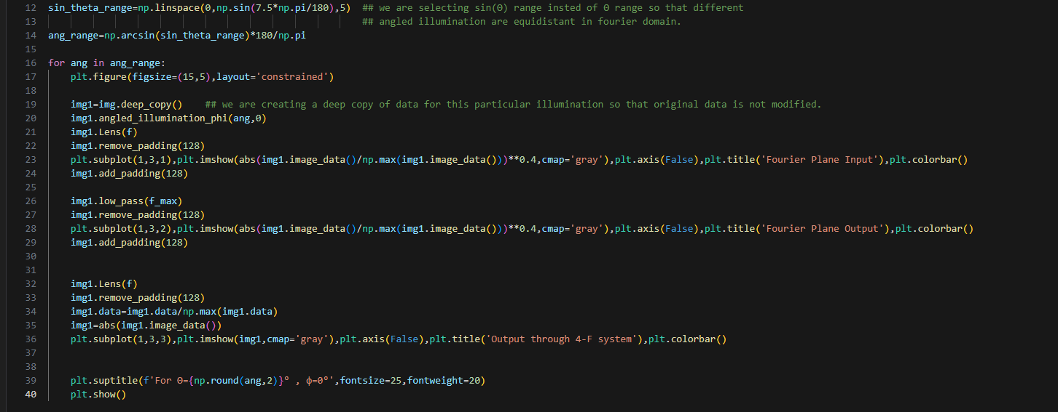

* 1. Repeating the code for different orientation of angled illumination: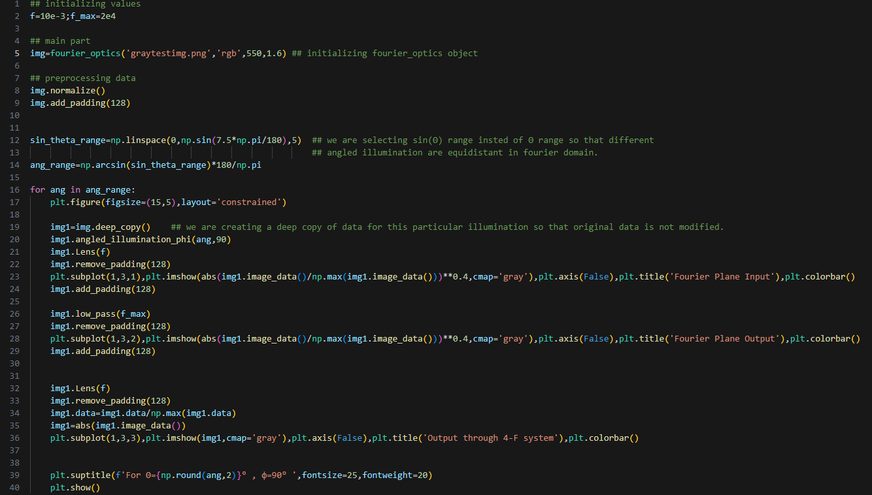

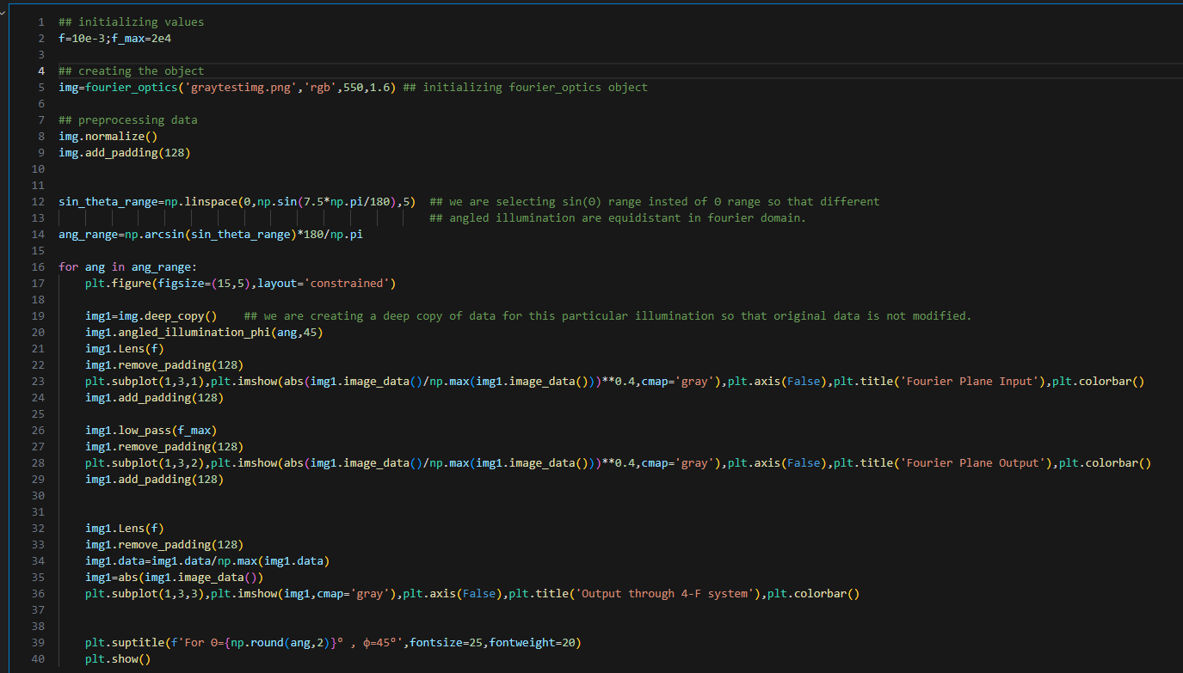

Extra Part:

Fourier Ptychography